1. Which of the following is (are) application(s) of deep learning?

 Video captioning

 Visual question answering

 Video summarization

 All of the above

1. Match the following:  
     
    A biological neuron consists of  
     
    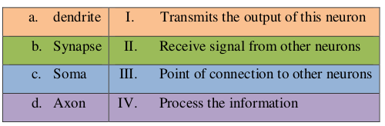

 a-II, b- III, c-IV, d-I

 a-I, b-III, c-II, d-IV

 a-IV, b-III, c-II, d-I

 a-I, b-II, c-III, d-IV

1. Which of the following Boolean function is not linearly separable?

 AND

 OR

 NOT

 XOR

1. Which of the following points are TRUE for McCulloch Pitts (MP) Neuron Model and Perceptron Model?  
     
    i. Inputs are not weighted in MP neurons  
    ii. Perceptron model can take weights with respective to inputs provided.  
    iii. MP neuron model process real inputs as well  
    iv. Perceptron model process real inputs as well

 i, ii

 i, ii, iii

 i, ii, iv

 i, ii, iii, iv

1. Which of the following statements is true for the Perceptron Learning Algorithm?  
     
    Statement I: Threshold needs to be hand coded  
     
    Statement II: Threshold can be learnt

 I & II

 I

 II

 None of the statements

1. Consider the following McCulloch Pitts unit in Figure 2. Identify the Boolean function for which the Neuron fires only if θ = 3.  
    Figure 2 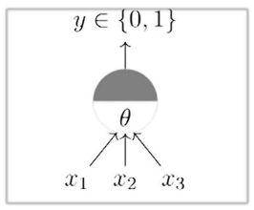

 AND

 OR

 NOR

 XOR

1. In sigmoid (logistic) function when WTX→∞, then sigmoid value is equal to

 0

 1

 ∞

 None of these

1. In sigmoid (logistic) function when WTX=0, then sigmoid value is equal to

 0

 1

 ∞

 0.5

1. Values (range) of unipolar sigmoid function are



−1⇿+1



−∞⇿+∞



0⇿1

 None of the above

1. Consider the following Figure, identify the function.  
     
    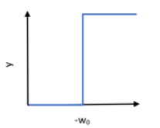

 Sigmoid

 Perceptron

 None of these

1. Which parameter(s) need to be learnt in minimizing objective function in supervised learning?

 Only Weight

 Only Bias

 Both Weight and Bias

 Learning rate

 None of these

1. The number of nodes in the input layer is 10 and the hidden layer is 6 (In MLP). The maximum number of connections from the  
       input layer to the hidden layer are

 72

 60

 More than 60

 120

1. Consider the following Feed Forward Neural Network:  
     
    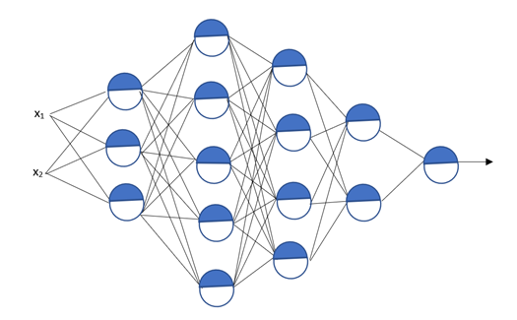  
     
       Find the number of hidden layers in the above figure:

 6

 5

 4

 2

1. Consider the figure in question:13. Find the number of neurons in the above figure in 2nd hidden layer:

 4

 5

 3

 2

1. Consider the figure in question:13. What is the dimension of the weight matrix to connect input to 1st layer?

 3 x 2

 3 x 3

 2 x 3

 None of the above

1. Consider the figure in question:13. What is the dimension of the first bias?

 2

 1

 3

 None of the above

1. Consider the figure in question: 13. Find the number of inputs.

 3

 2

 1

 None of the above

1. Which of the following method is used at the output layer for classification?

 Linear

 softmax

 Linear or softmax

 None of these

1. In regression problem, which of the following loss function will be used?

 squared error loss

 cross entropy

 None of these

1. Which of the following statement(s) is/are correct with respect to the bias?

I.  Complex model has a low bias

II. Simple model has a low bias

III.  Complex model has a high bias

IV.  Simple model has a high bias

 II, III

 I, II

 III, IV

 I, IV

1. Bias is defined as



f^(x)=E[f^(x)]−f(x)f^(x)=E[f^(x)]−f(x)



f^(x)=1−f(x)f^(x)=1−f(x)



f^(x)=f(x)f^(x)=f(x)

 None of these

1. Dropouts result in

 Dropping out some units

 It results in a thinned network

 Typically, each node is retained with fixed probability (0.5 for hidden units and 0.8 for visible nodes)

 All of these

1. While training a neural network for face recognition, mention the most appropriate place for early stopping.

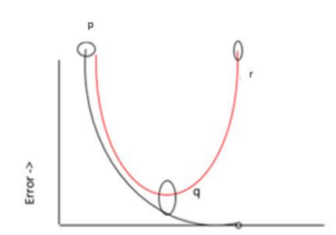

 p

 q

 r

 None of these

1. Mostly parameter tying used in

 Convolutional neural networks

 Recurrent neural networks

 Autoencoders

 All of these

1. The dimension of the hidden layer is less than the original input layer.” Which of the following encoder follows above statement?

 Under complete autoencoder

 overcomplete autoencoder

 Sparse autoencoder

 Denoising autoencoder